Smart Compactor Shelving Management System

User Manual

Model:15.6-inch industrial control computer
Version: V6.0.0

July 2026

Table of Contents
一、 System Login 3
1.Password Unlock 3
二、 Intelligent Shelving System 4
1. Open-shelf operation 4
(1) Move Left 5
(2) Move Right 5
2. Close-shelf operation 5
3.Stop 5
4.Unlock 5
三、 System Settings 6
1. Area Col Set 7
(1)Position Parameters 7
(2)Running Parameters 8
2. Advanced 9
(1)Timing Settings 9
(2)Information Settings 9
(3)Other Settings 9
3. User Mgmt 10
(1)Add User 10
4. Support 11
(1)Hardware Config 11
(2)Software Version 11
(3)Hardware Version 11
(4)Tel 11
(5)E-mail 11
(6)Web 11

System Login

1.Password Unlock
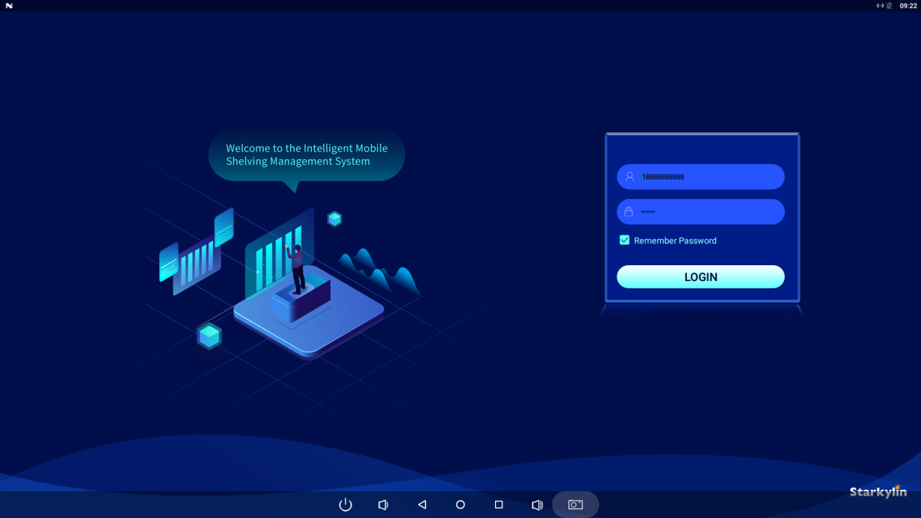

The account is a phone number.
Default Account：18888888888
Default password：123456

Intelligent Shelving System

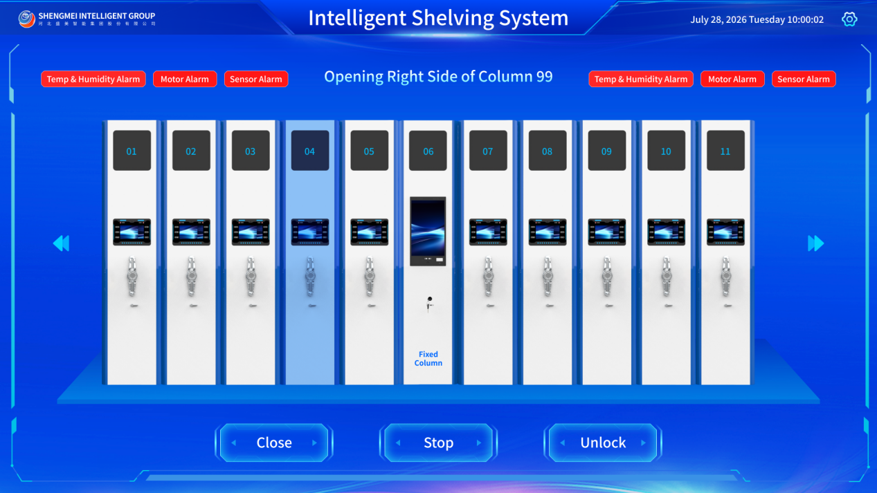

Open-shelf operation
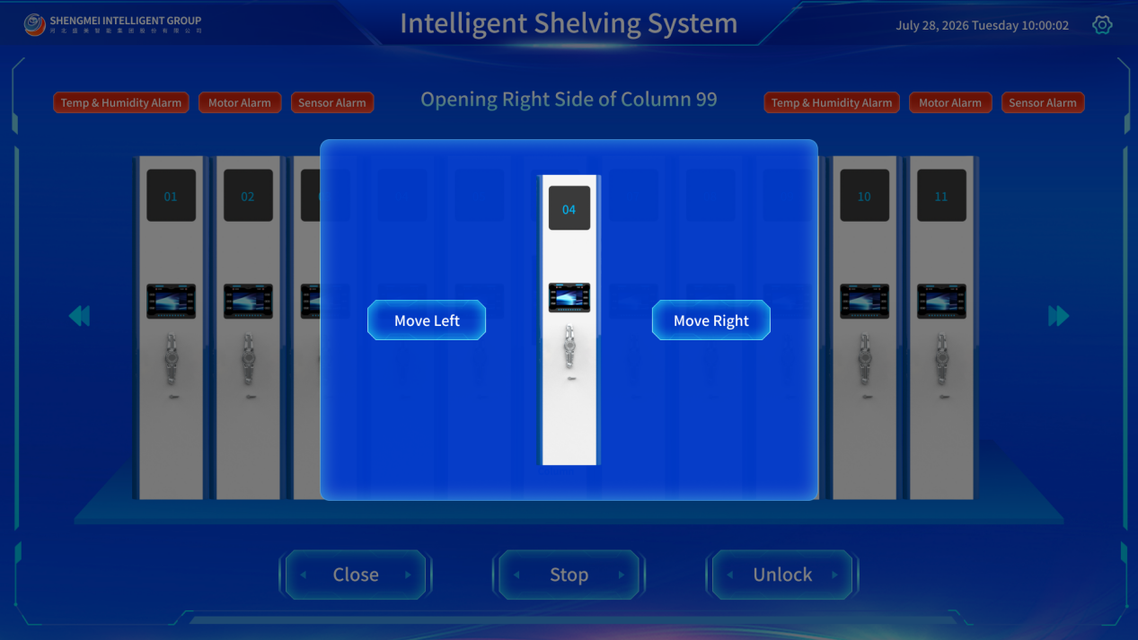

Move Left

Move Right

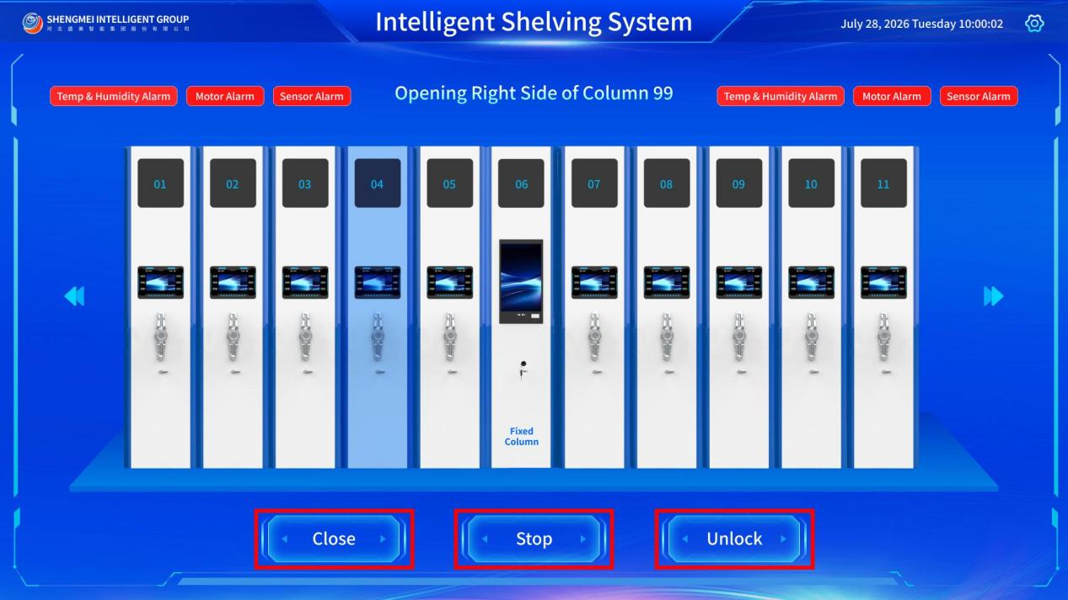

Close-shelf operation

3.Stop

4.Unlock

System Settings
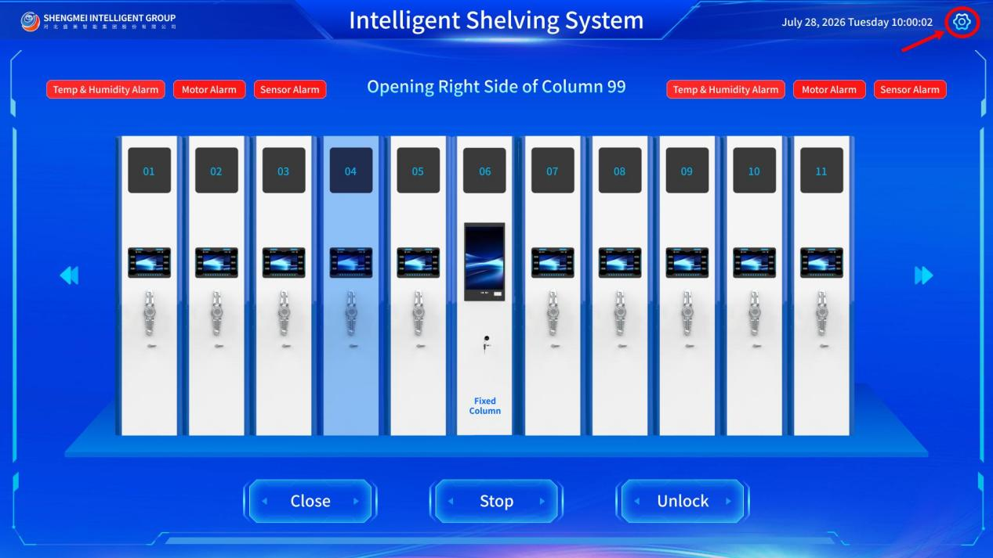

Area Col Set
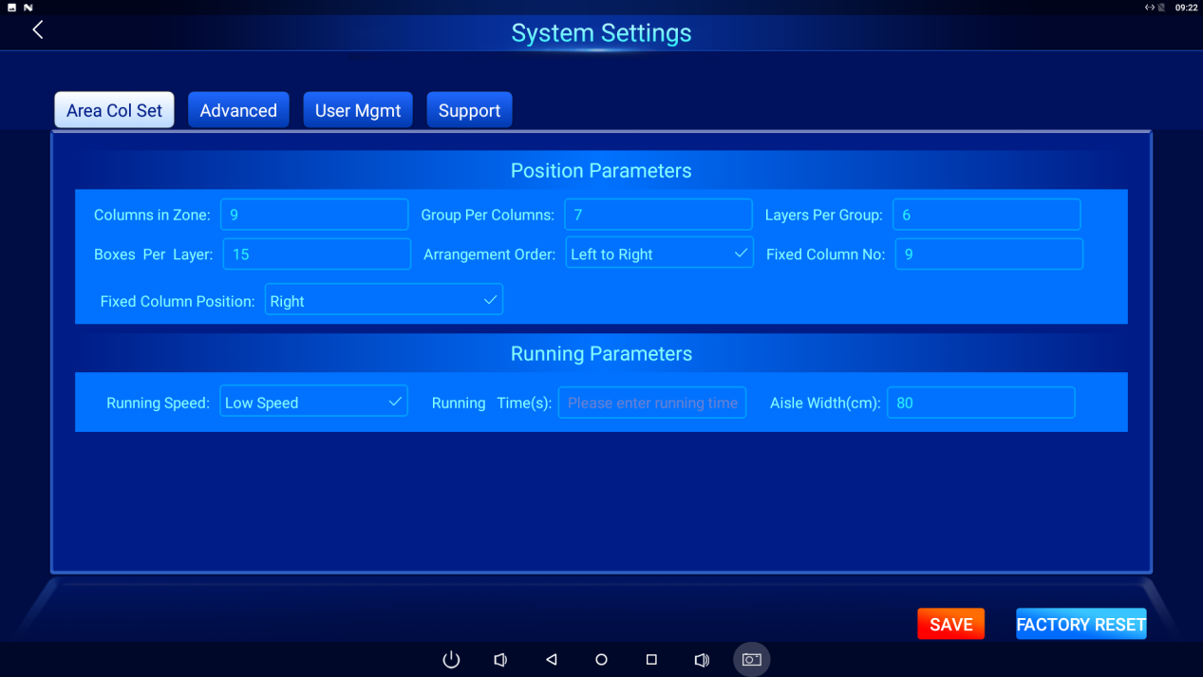

(1)Position Parameters

1)Columns in Zone

2)Group Per Columns

3)Layers Per Group

4)Boxes Per Layer

5)Arrangement Order
You can set three sorting modes: left‑to‑right, middle‑fixed, and right‑to‑left.

6)Fixed Column No

7)Fixed Column Position
Fixed column positioning can be configured in three ways: left fixed, center fixed, or right fixed.

(2)Running Parameters

1)Running Speed
Set operating speed: High, Medium, Low

2)Running Time
Set a maximum operation time; if the scaffold is not in place beyond this time limit, a timeout alarm will be triggered, and the scaffold will stop.

3)Aisle Width
The maximum travel distance setting prevents derailment; if the scaffold exceeds this maximum distance, an over-distance alarm will be triggered, and the scaffold will stop.

Advanced
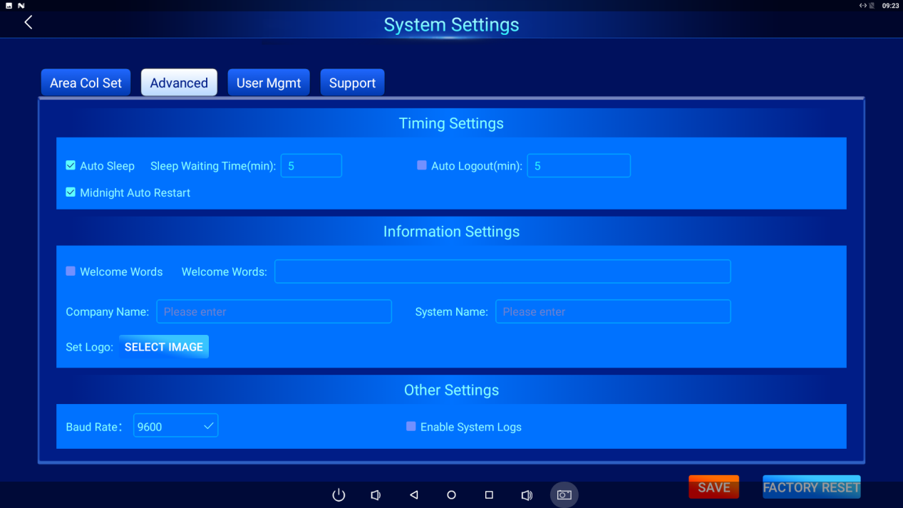

(1)Timing Settings
Enable automatic sleep mode; set the duration before automatic sleep upon idle period; set the duration before automatic logout upon idle period; enable automatic reboot at midnight.

(2)Information Settings
Whether the welcome message on the login page is enabled and the content of the welcome message; settings for the company name on the homepage, the system name, and the logo.

(3)Other Settings
Serial port baud rate configuration and whether the system log is enabled.

User Mgmt

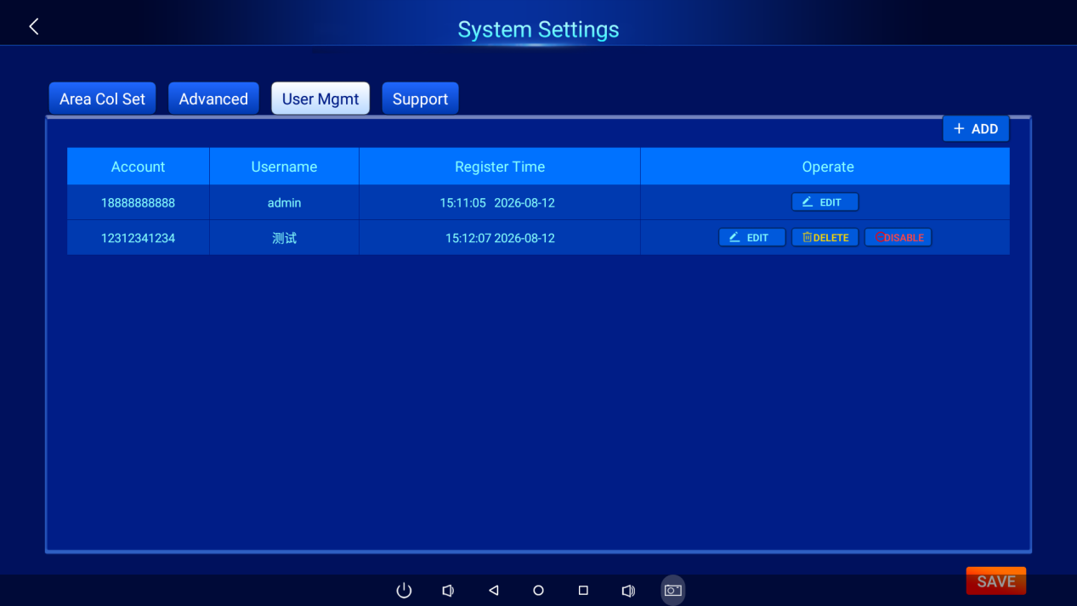
The administrator account can modify, disable, or delete users.

(1)Add User
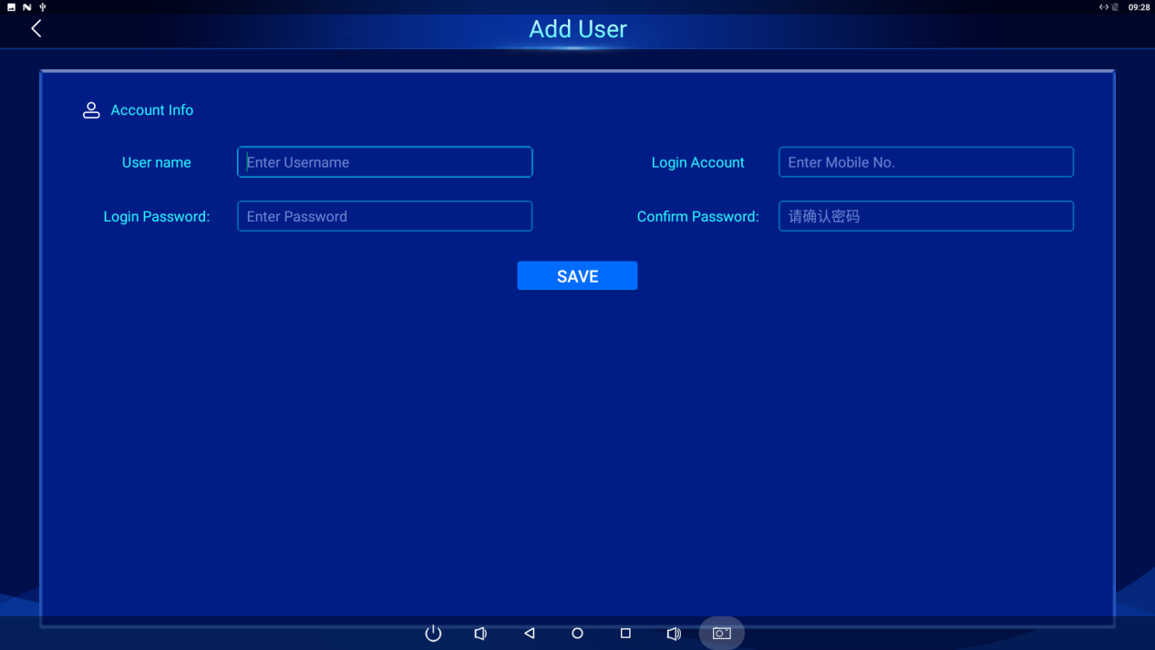
Add a new user: set a username, account (an 11-digit phone number), and password.

Support

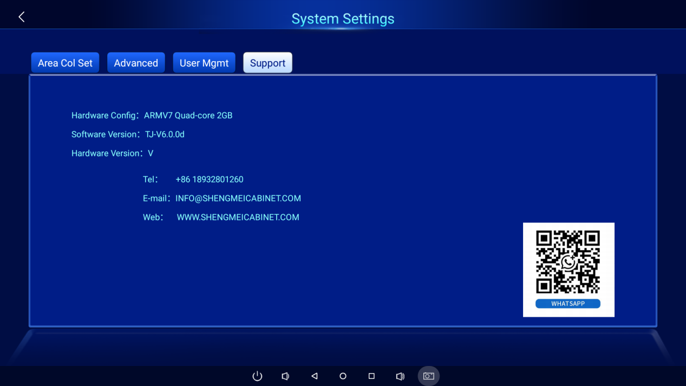

(1)Hardware Config

(2)Software Version

(3)Hardware Version

(4)Tel

(5)E-mail

(6)Web

